SOP: Reports, KRA, QC Results and My Roster (Agents)
Module | Reports, KRA, QC Results and My Roster (Agents)
Who uses it | Agent
Version | 1.0
Issued | 21 Oct 2026
Screenshots are taken from the HRMS test copy. Names, dates and numbers are examples only.

1. Purpose
Agents use Analytics to follow their billable hours, monthly goal, QC results and KRA, to upload corrected or reworked files, and My Roster to see their schedule.

2. Analytics > Overview
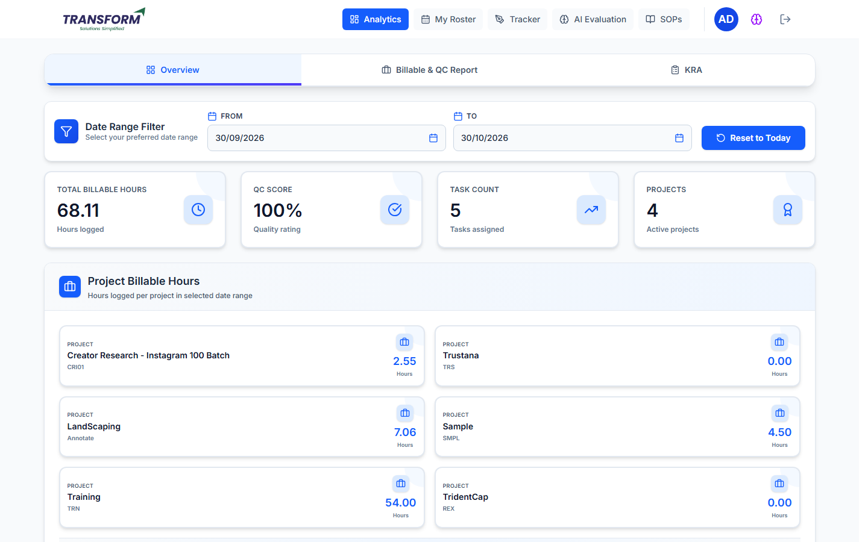
Figure 1: Overview
Quick view of your hours for the selected dates.

3. Billable & QC Report

3.1 Daily Report
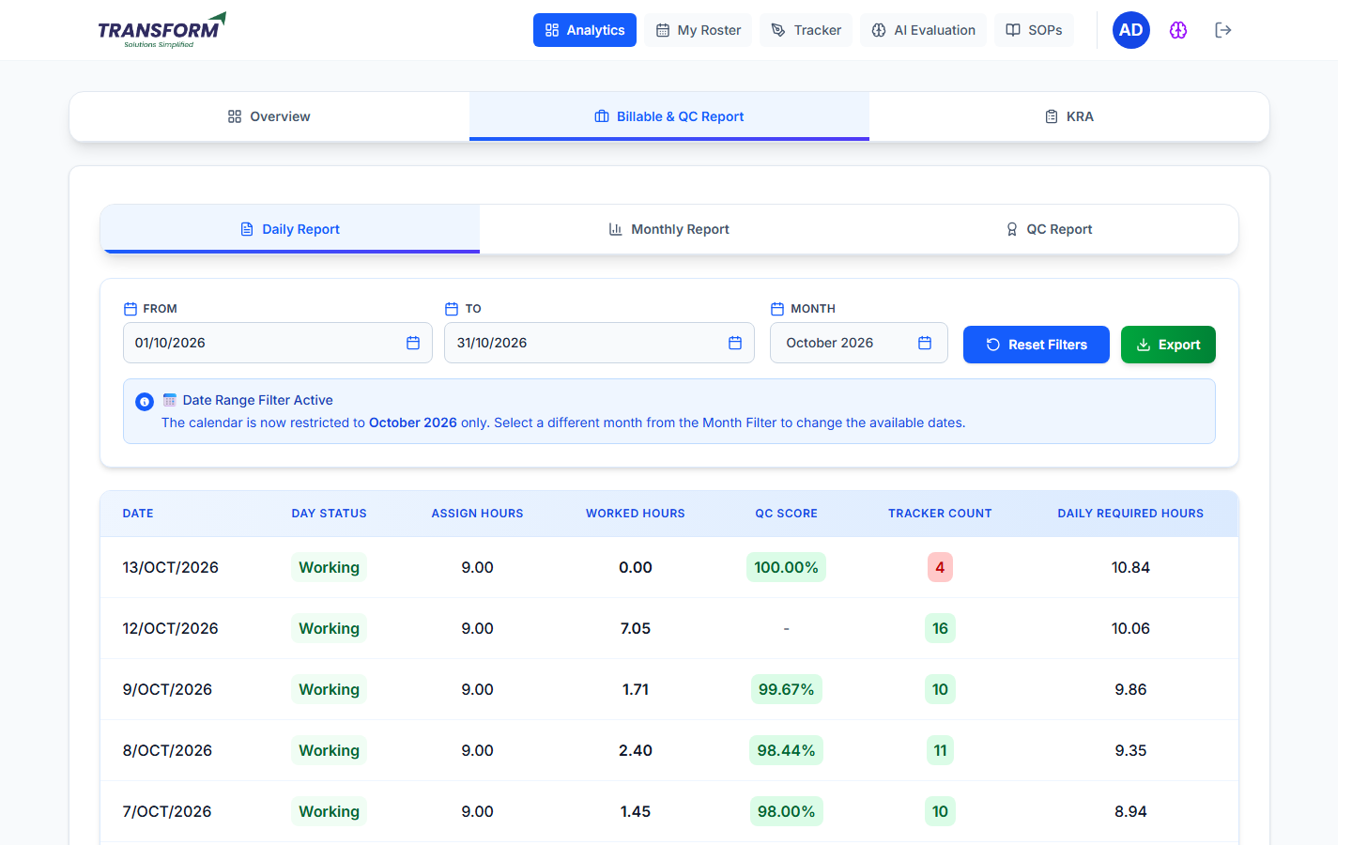
Figure 2: Daily Report
Column | Meaning
Date / Day Status | The day and its roster status (Working, Week Off, Leave ...).
Assign Hours | Hours expected that day from the roster.
Worked Hours | Billable hours from your tracker entries.
QC Score | Average QC score of that day's files (blank until QA checks them).
Tracker Count | Number of tracker entries that day.
Daily Required Hours | Hours you need per remaining day to reach the monthly goal.

Use From / To (within the chosen Month), Reset Filters and Export.

3.2 Monthly Report
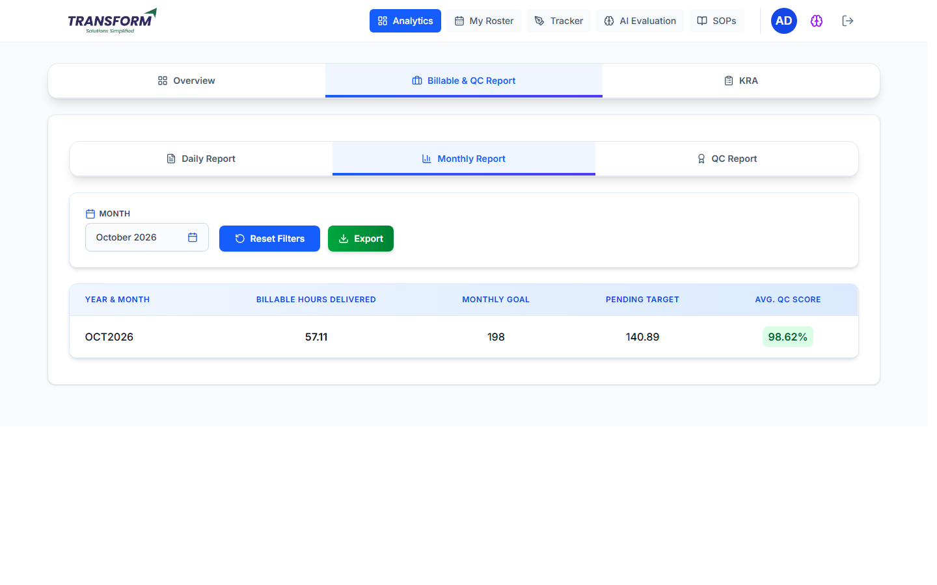
Figure 3: Monthly Report
Billable Hours Delivered, Monthly Goal, Pending Target (goal minus delivered) and Avg. QC Score for the month. Choose another month with Month; Export downloads it.

3.3 QC Report - results and re-uploads
1. Open QC Report. Each file shows QC Date, File Submission, Project / Task, Score, Status (Regular, Correction #n, Rework #n), QC Status and Errors. Click View to see each error with its QC Code and points.
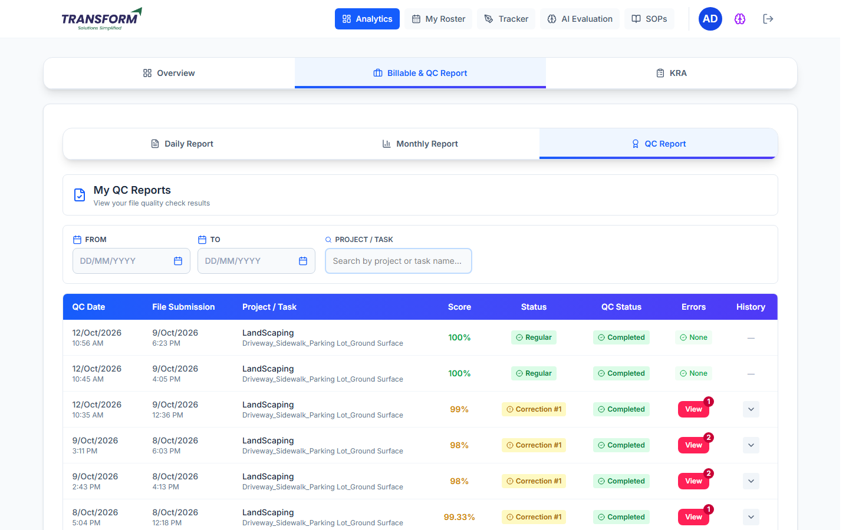
Figure 4: My QC Reports
2. Click the arrow in History to open the QC History of a file: every correction/rework attempt with its QC date, status, score, errors and file.
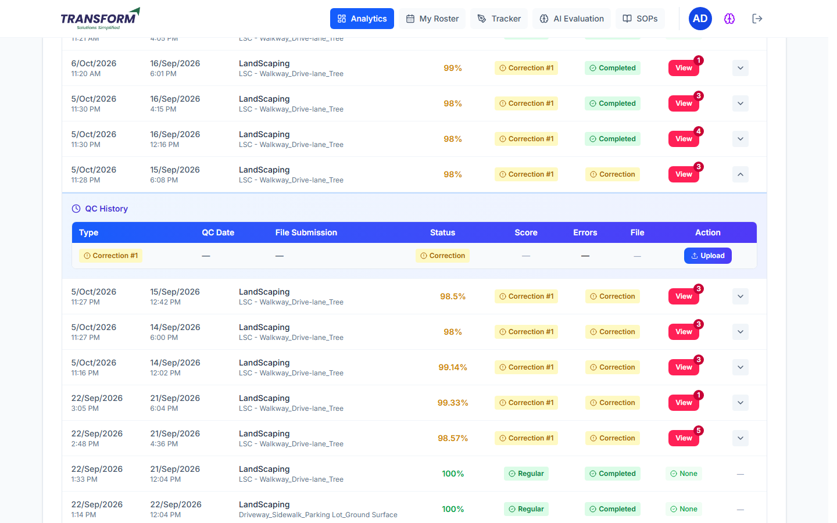
Figure 5: QC History - Correction #1 open
3. On the open attempt click Upload, choose the corrected (Correction) or reworked (Rework) Excel/CSV file and click Submit.
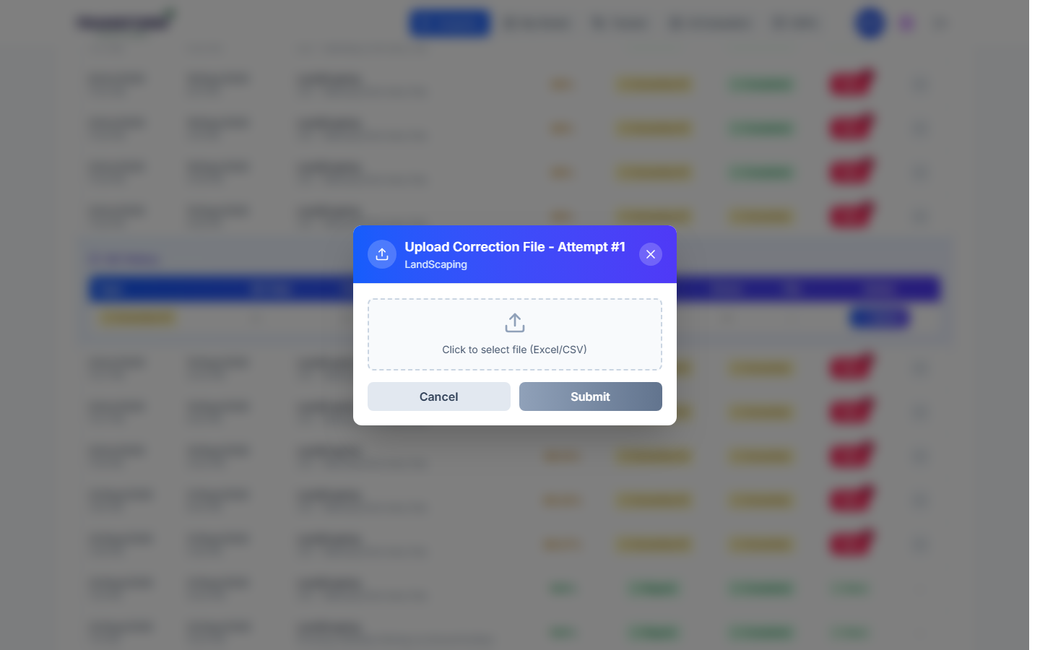
Figure 6: Upload Correction File
4. The status changes to 'Under Review'. QA checks it again and the result appears here.
Status | What you do
Regular / Passed | Nothing. The file passed.
Correction | Fix only the marked rows in the marked sample and upload it.
Rework | Fix all errors across the whole file and upload it.
Under Review | Wait. QA is checking your upload.

4. KRA
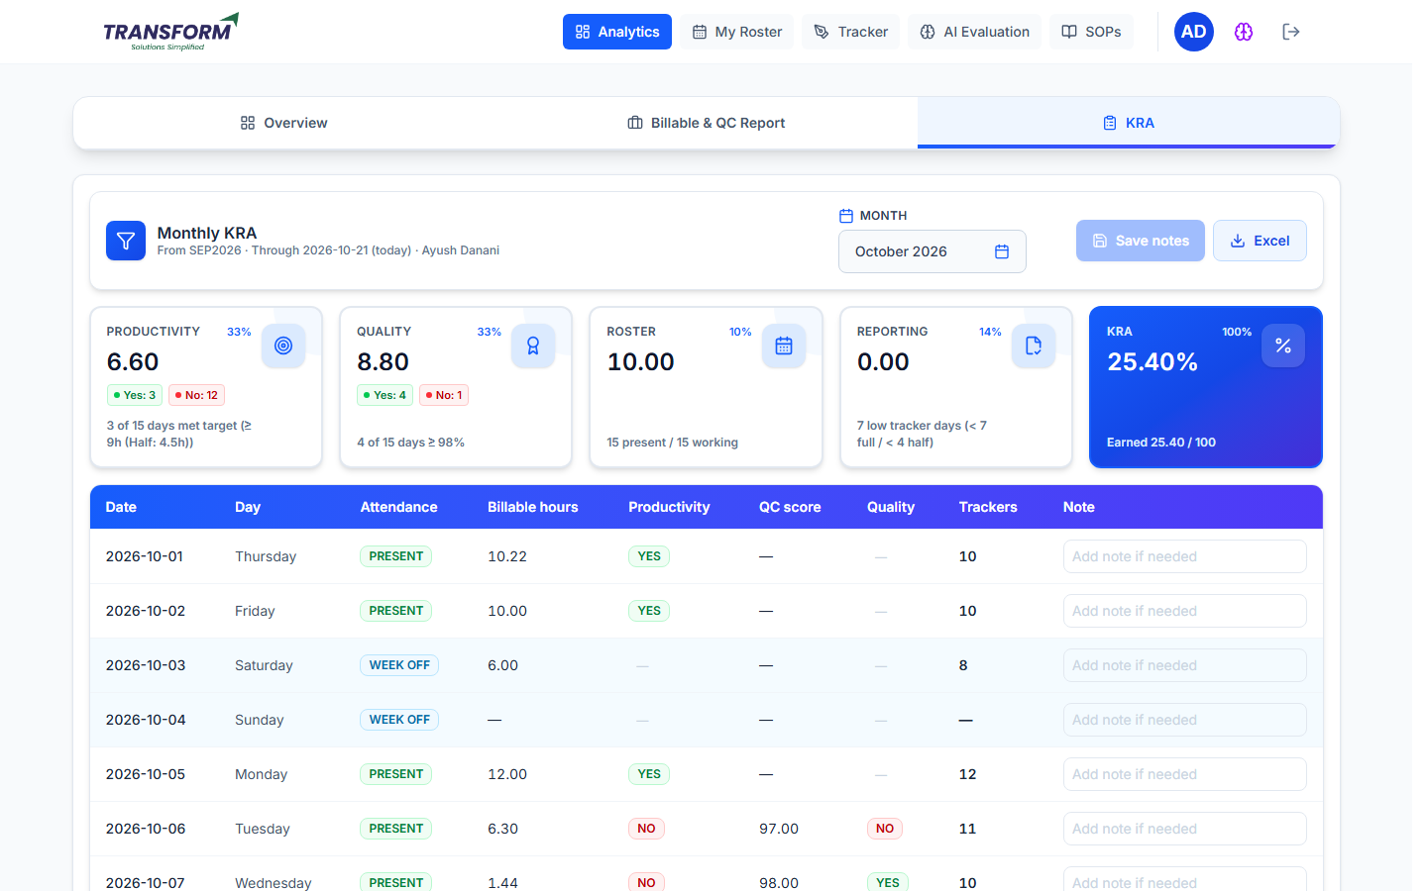
Figure 7: Monthly KRA
- Choose the month. Cards: Productivity 33%, Quality 33%, Roster 10%, Reporting 14% and the overall KRA %.
- Productivity: a day is Yes when billable hours reach 9 (4.5 on a half day).
- Quality: a day is Yes when the QC score is 98% or more.
- Reporting: days with fewer than 7 trackers (4 on a half day) count as low tracker days.
- Roster: present days against working days. The table lists every day; Excel downloads it.

5. My Roster
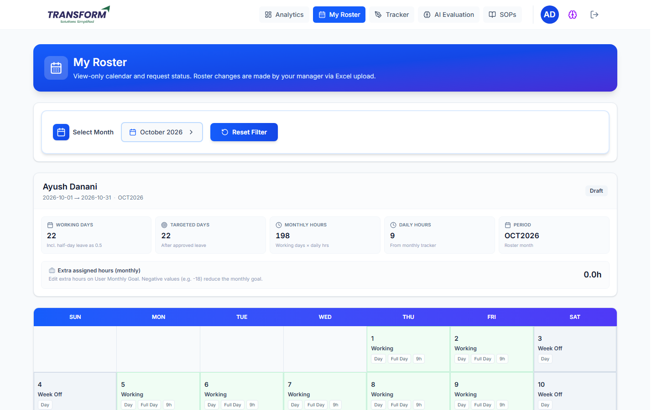
Figure 8: My Roster
Your days for the month (working, shift, week off, leave, holiday). Ask your manager for any change; it goes to admin for approval.

6. Common problems
Problem | What to do
QC Score is blank | QA has not checked that day's files yet.
No Upload button | The attempt is Under Review or already closed.
Numbers look wrong for a day | Check your tracker entries and your roster for that day.

